Supplier Database
Query 1: Using Scheme diagram, create tables by properly specifying the primary keys and the foreign keys.
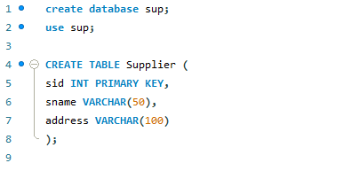
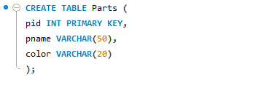
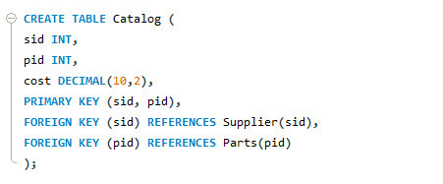

Query 2: Insert appropriate records in each table.
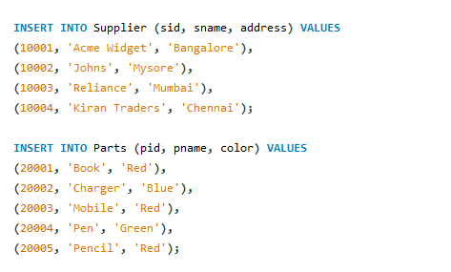
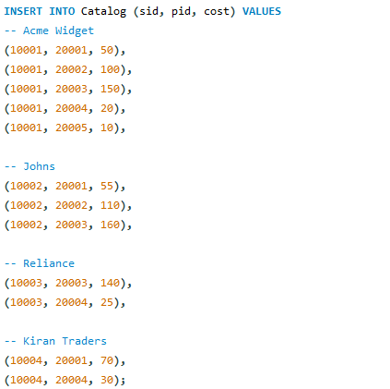
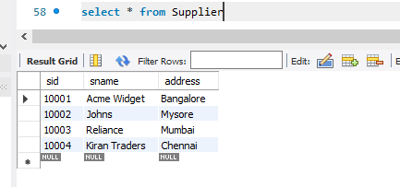
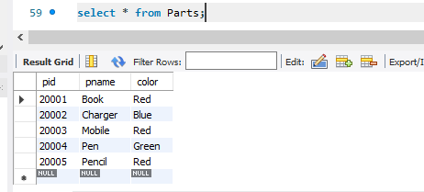
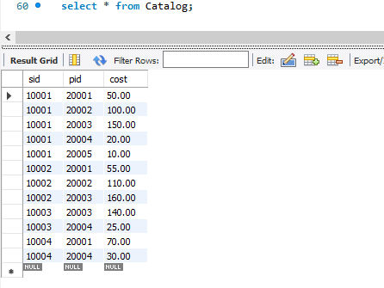

Query 3: Find the pnames of parts for which there is some supplier.
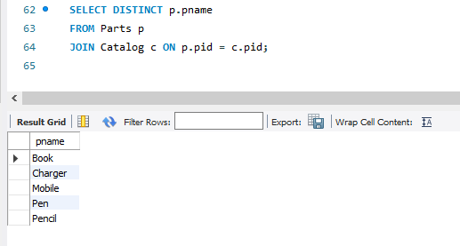
Query 4: Find the snames of suppliers who supply every part.
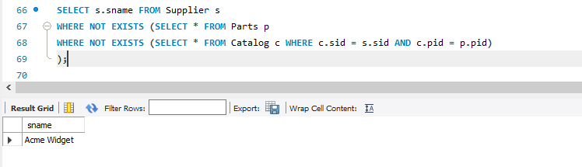
Query 5: Find the snames of suppliers who supply every red part.
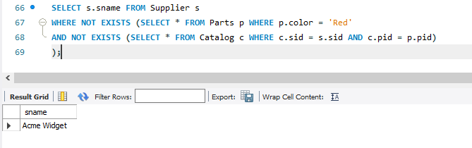
Query 6: Find the pnames of parts supplied by Acme Widget Suppliers and by no one else.
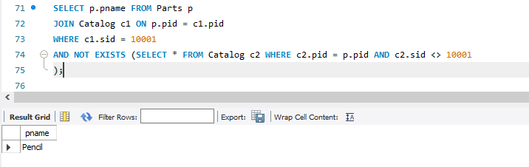
Query 7: Find the sids of suppliers who charge more for some part than the average cost of that part (averaged over all the suppliers who supply that part).
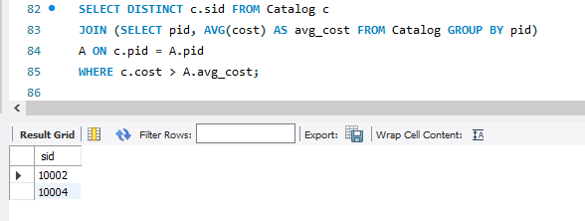
Query 8: For each part, find the sname of the supplier who charges the most for that part.
